# Survey on Safe Routes to School in SOmerville

We are students and researchers at Harvard University Graduate School of Design, and we created this survey as part of a project to help us find out which places Somerville could improve to make it easier and safer for children to walk and bike to school.  
  
We are also trying to find out how people choose which route they will take to walk or bike to school.  
  
You can help us with our project by answering the questions in this survey. We think it will take you less than 10 minutes to answer all the questions.   
  
Taking this survey might have a risk that you feel anxious when you answer questions about unpleasant or uncomfortable environments you or your child encounter on their journey to school. You do not have to take this survey, and if you do choose to take it, you do not have to answer any questions you do not want to.  
  
There are no benefits from taking this survey, but we hope that your answers might help us think of ways to make streets safer and better for other children.

To thank you for taking the survey, we can send you a $10 Amazon gift card when you are done. If you would like us to send you a gift card, you can write an email address we should send it to at the end of the survey. We will keep the email addresses separate from the surveys so that your answers to the survey questions will still be anonymous (we will not know which answers came from which person).  
  
If you have any questions about this survey, you can email Carole Voulgaris at cvoulgaris@gsd.harvard.edu.



If you wish to take this survey on paper, please check this box to show that you understand the information on this page and you agree to take the survey.

* I understand the information on this page, and I agree to take this survey.

The questions in this survey refer to your child who attends Benjamin G. Brown School or Winter Hill Community Innovation School. If you have more than one child at these schools, you may take the survey more than once.

If you do not know the answers to some of the questions about how your child gets to school, it is okay to ask your child, or to skip those questions.

Which school does your child attend?

* Winter Hill School (at Edgerly)
* Winter Hill School (at Capuano)
* Benjamin G. Brown School
* Other______________________

What grade is your child in?

* Pre-K
* Kindergarten
* 1st grade
* 2nd grade
* 3rd grade
* 4th grade
* 5th grade
* 6th grade
* 7th grade
* 8th grade

What pronouns does your child use?

* She/her
* He/him
* They/them
* Other______________________

Who does your child usually travel to school with? You can choose more than one answer.

* By themself
* With an adult they live with
* With an adult they do not live with
* With a child they live with
* With a child they do not live with

Who decides how your child gets to school most mornings (e.g. by car, walking, bike, or bus)?

* I (perhaps along with any other caregivers) decide how my child gets to school
* My child can choose how they will get to school
* Other: ____________________________

Draw an X on the map at a spot at or near where your child lives.

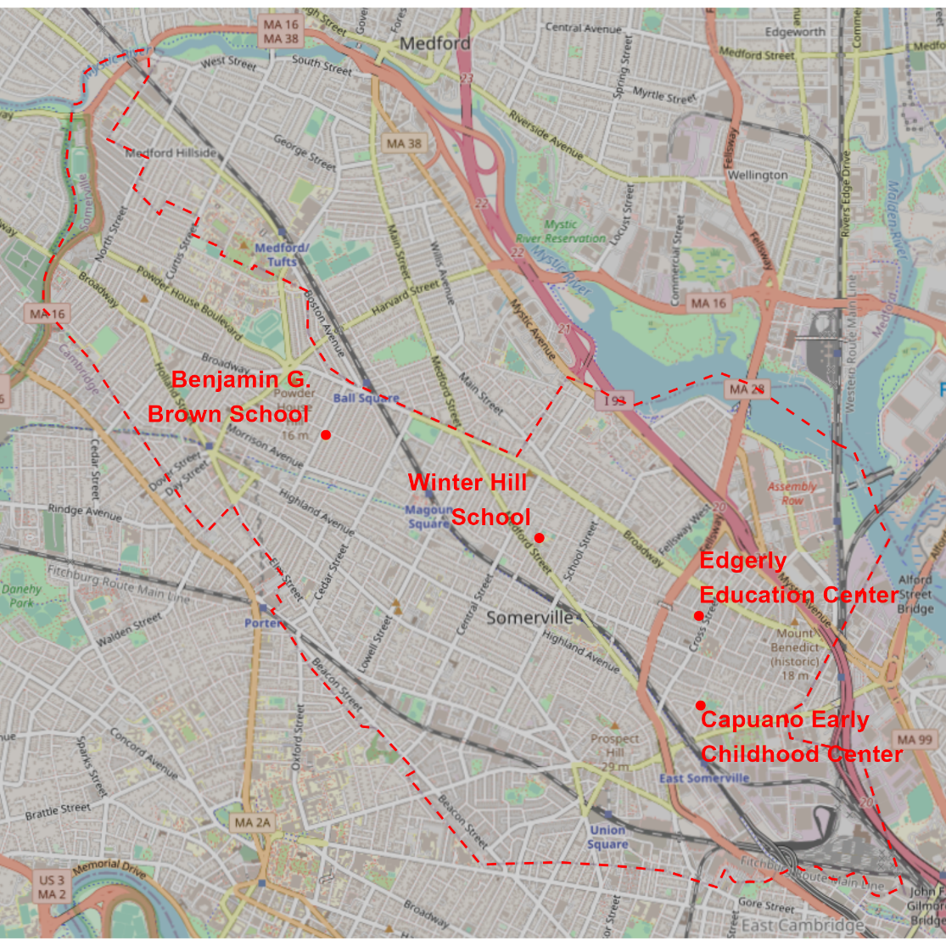

What is the main way your child gets to school most mornings?

* In a car (go to page 4)
* On a bike (go to page 8)
* Walking (including a wheelchair or other mobility device) (go to page 8)
* On an MBTA bus or train (go to page 7)
* On a school bus (go to page 5)
* Another way: ______________________

What is the main reason your child does not usually walk to school?

* It is not safe.
* It would take too long.
* There is no one to go with them.
* Other ________________________________

What is the main reason your child does not usually ride a bike to school?

* We do not have a bike for them.
* They do not know how to ride a bike.
* It is not safe.
* It would take too long.
* There is no one to go with them.
* Other ________________________________

Go to page 17.

Where does the school bus pick your child up in the morning?

* At Winter Hill School (115 Sycamore Street) (go to page 6)
* At or near their home (go to page 17)
* Another location (go to page 17)

For the rest of this survey, “school” means the Winter Hill School at 115 Sycamore Street, where the bus picks your child up.

How does your child usually get to school (the Winter Hill School at 115 Sycamore Street) in the morning?

* In a car (go to page 4)
* On a bike (go to page 8)
* Walking (including with a wheelchair or other mobility device) (go to page 8)
* On an MBTA bus or train (go to page 7)

Draw an X on the map at spots at or near where your child gets on and off the bus or train. If they take more than one bus or train, show where they get on the first one and where they get off the last one.

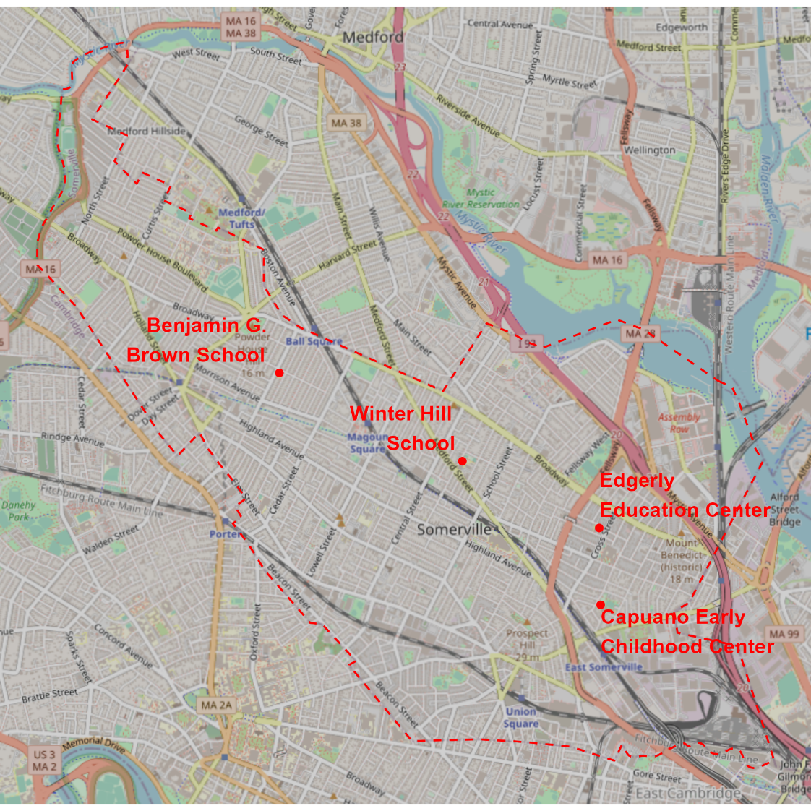

Go to page 11.

When your child goes to school in the morning, do they usually go straight to school, or do they stop somewhere else first?

* They go straight to school (go to page 11)
* They stop somewhere in Somerville first (go to page 9)
* They stop somewhere outside of Somerville first (go to page 10)

What is the reason for your child making a stop on their way to school?

* To drop someone off at their work, school, or daycare
* To meet someone who takes them to school or travels to school with them
* Something else ____________________

Draw an X on a spot at or near the last place your child stops on the way to school.

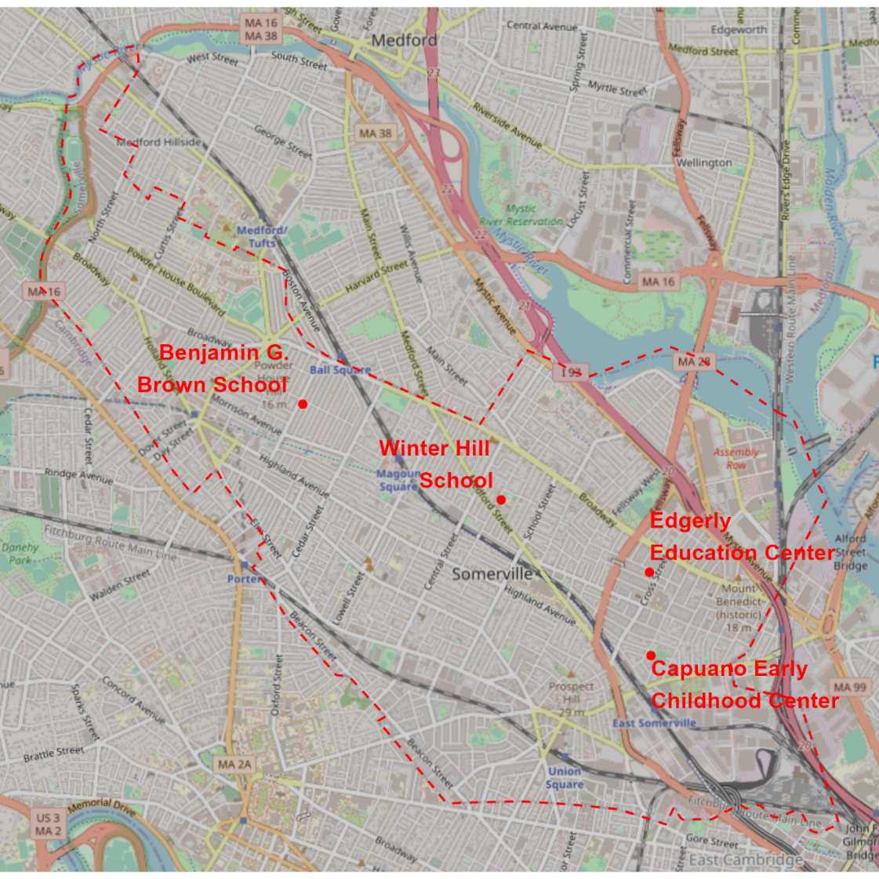

Go to page 11.

What is the reason for your child making a stop on their way to school?

* To drop someone off at their work, school, or daycare
* To meet someone who takes them to school or travels to school with them
* Something else ____________________

Draw an X on a spot on the Somerville boundary (the red dashed line) that your child passes by on their way to school after making a stop outside of Somerville.



Go to page 11

Draw the route your child usually takes to walk or bike to school (from home, an MBTA bus stop, or the last stop they make on the way to school).



Who decides what route your child will take to walk or bike to school?

* I (perhaps along with any other caregivers) choose the route my child takes to school
* My child can choose their route to school
* Other: ____________________________

Is this the shortest (most direct) route your child could take to school?

* This is the shortest route they could take (go to page 15)
* There are other routes they could take that are about the same distance, but I or they prefer this one (go to page 12)
* There are shorter routes they could take, but they go out of their way to take this one (go to page 12)

Why do you and/or your child prefer their usual route to others that are the same distance or shorter (you can choose more than one answer)?

* It avoids places that are unsafe because of traffic
* It avoids places that are unsafe for other reasons
* It avoids locations with bad sidewalks
* There are more interesting things to see along the way
* It is more separate from traffic
* Other _________________________

Draw the shortest route your child could take to walk or bike to school (from home, an MBTA bus stop, or the last stop they make on the way to school).



Circle up to five places your child would pass along the shortest possible route to school that are worse than the places they pass on the route they usually take to school.



What is wrong with these places?

___________________________________________________________________________________________________________________________________________________________________________________________________________________________________________________________________________________________________________________________________________________________________________________________________

Circle up to five places that are nice to walk or bike through along your child’s usual route to school.



What is nice about these places?

___________________________________________________________________________________________________________________________________________________________________________________________________________________________________________________________________________________________________________________________________________________________________________________________________

Circle up to five places that are unpleasant to walk or bike through along your child’s usual route to school.



What is unpleasant about these places?

___________________________________________________________________________________________________________________________________________________________________________________________________________________________________________________________________________________________________________________________________________________________________________________________________

Thank you for taking this survey!

We would like to send you a $10 Amazon gift card to thank you for your time. Please write the email address we should send it to:

__________________________________________________________________________

Would it be okay for us to use that email address to invite you to participate in future surveys, interviews, or focus groups about how kids travel to school?

* Yes
* No

Would you like us to send you a summary of the results of this survey and related research?

* Yes
* No